DGuidelines for information extraction from pdfs – Raship
TEMPLATE 1 ONE
(LEAD EXAMPLE: 178346_REINALDO SILVERA FERRARI)
General guidelines
Work with the excel templates in the folder "02_excel_templates"
Copy and paste the corresponding template and then change the name:
For example, when extracting the information from the pdf called "178346_REINALDO SILVERA FERRARI ", use that name for the excel.
After finishing extracting the information:
Move/upload the excel file into the folder "03_clean_excel_files/template_1_ONE"
Move the PDF file from the folder "00_original_pdfs" into the folder "01_done_pdfs"
Use commas as thousand separators: Instead of writing 600.000 for example, you should write 600,000.

How to recognize template 1 ONE??
Template 1:
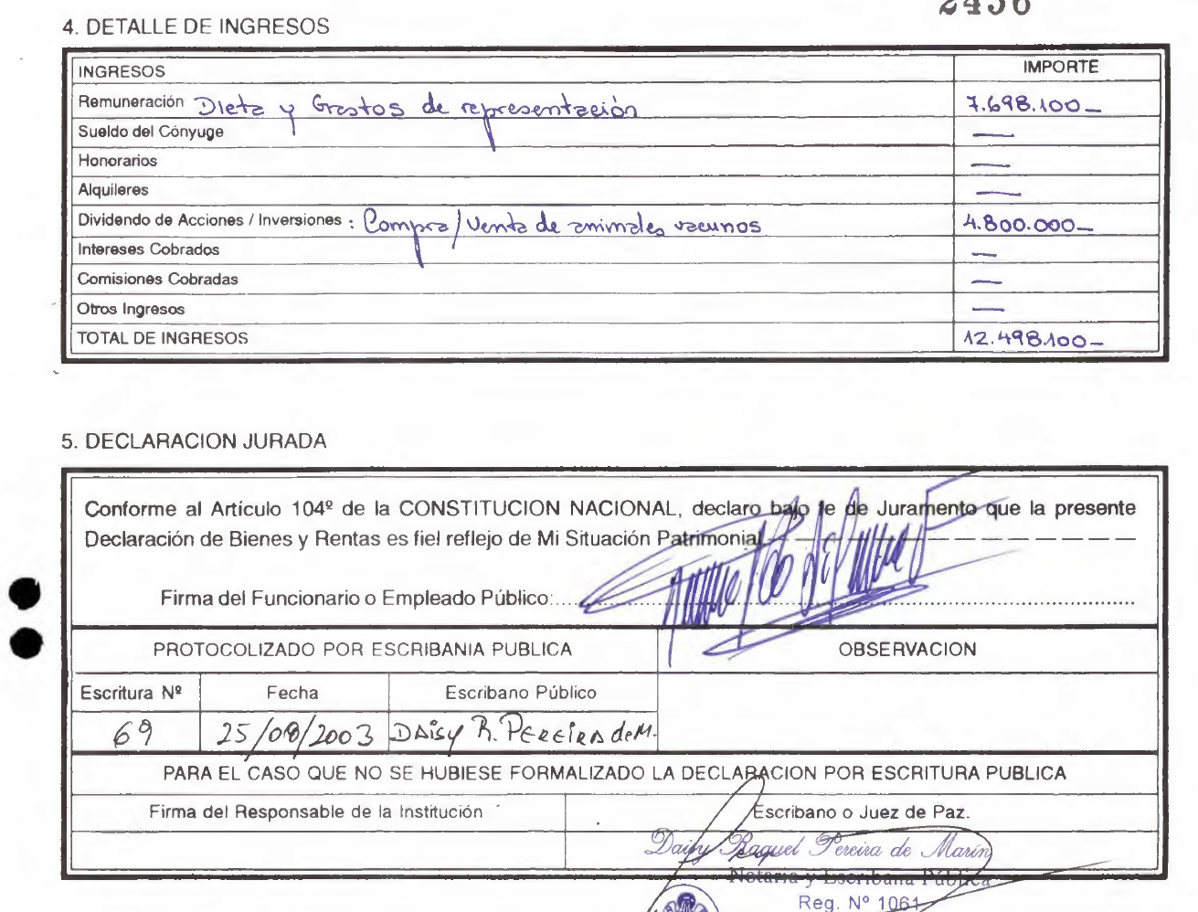
- Look for the titles of the sections 4 and 5: They are called “4. DETALLE DE INGRESOS” and “5. DECLARACION JURADA” correspondingly:

- Also, inside of the section “3. ESTADO PATRIMONIAL AL:”, subsection “3.1 ACTIVO”, the rest of the headers do not have numbers, for example:

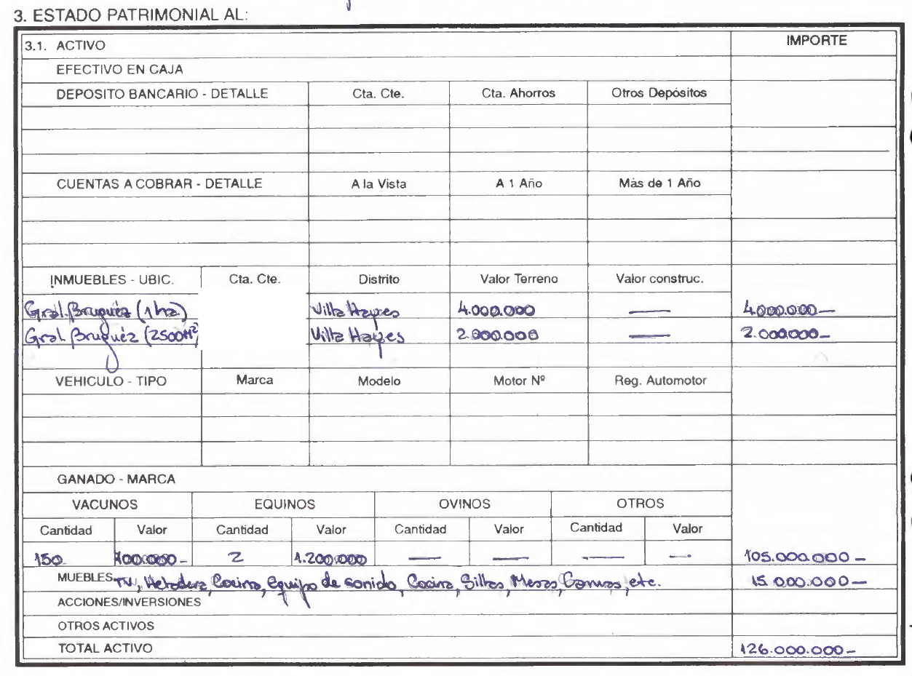
(however notice that inside the excel file the subsections (sheets) DO have numbers)
Specific guidelines
1_datos_personales
- The first column "Marcar la casilla correspondiente" refers to this occasional appearance:

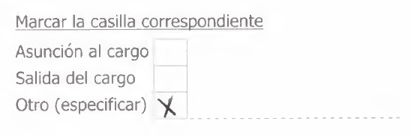

- The column "file_name" should be the name of the pdf with the extension at the end. For example:
178346_REINALDO SILVERA FERRARI.pdf

- fecha_dia_mes_ano:
If this information is blank:
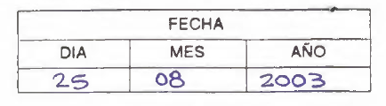
Look for a STAMP or SEAL, and input the date there, example:
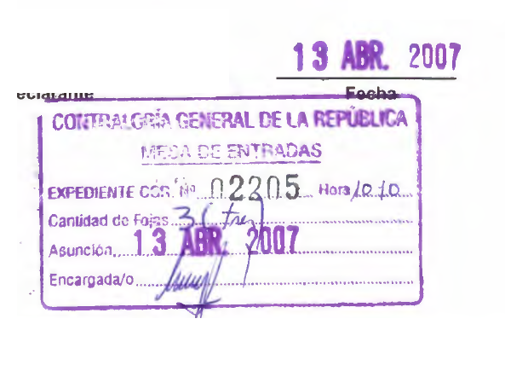
Would be inputted as 13/04/2007 (format of date in South America is DAY/MONTH/YEAR so careful with that)

CAREFUL: sometimes there’s no stamp, but there is something written on the side, usually very close to the box previously shown. Example:

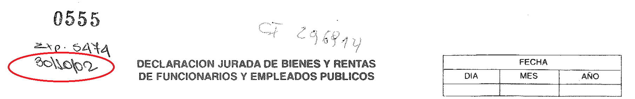

In this case what would be inputted is 30/10/2002

- If some variables (columns) are blank in the pdf, leave them blank in the excel.

2_informacion_laboral

- The third column in this sheet is called "tipo de funcionario(nombrado,electivo,otros)" and sometimes it doesn't show up. But when it does, it shows up like this:

- "cargo_o_funcion" and "categoria de funcionario" are TRICKY SOMETIMES. If they didn't write anything, you can check what they have underscored or selected here:
(In this case, you should input the word "Intendente" both in "cargo_o_funcion" and "categoria de funcionario", unless there was already something written there.)

3_efectivo_y_depositos

3_cuentas_a_cobrar

3_inmuebles

3_vehiculos

3_ganado
You can leave the importe column here blank, for example, in the following case, no need to write 105,000,000:
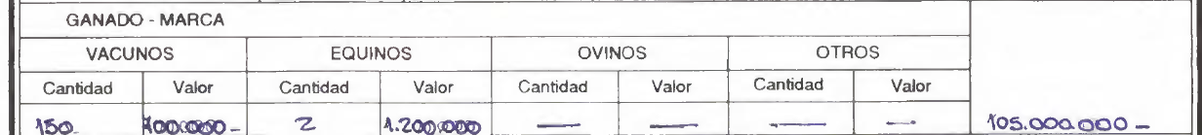

3_acciones_inversiones_bono

3_muebles

3_otros_activos

3_2_pasivo

3_3_resumen

4_detalle_de_ingresos
Whatever is in handwrite or typed should be in the second column, called “type”, example:
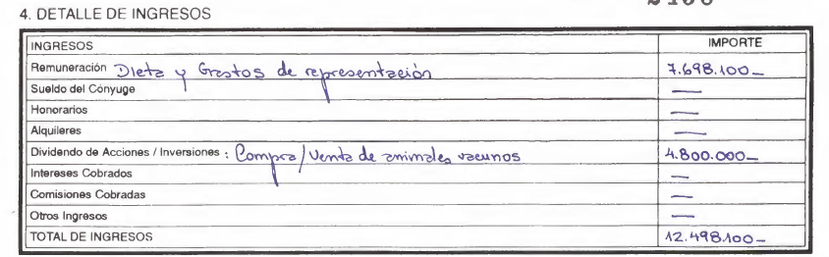

Gets inputted into the excel as:

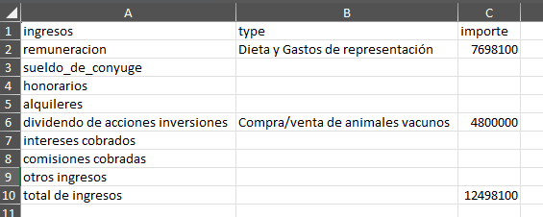

5_declaracion_jurada
- Check what is the name on top of the words "Escribano Publico", in the SEAL/STAMP. Sometimes it can say ``Notario" or ``Notaria"
EXAMPLE:
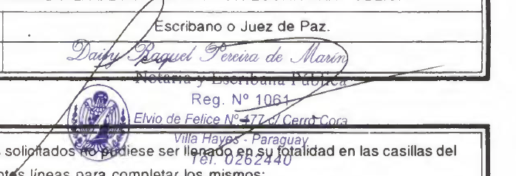
Sometimes you will not find anything there, neither for escribano public nor observation. But most of the time I think you will find some seal with the word escribano there. (In this case you should write “Daisy Raquel Pereira de Marin”)

observacion
If this is blank, leave it blank.
If it has information, write “see pdf”

